Research Question:
Can male hamster learn to finish the maze faster and better than female hamster?
In this experiment, faster is defined as the time that each hamsters take to finish the maze in which the one that use less time will be considered “faster.” A term “better” is defined referring to the hamster’s ability to learn and improve depending on the times that each hamsters uses to finish the maze. The one that take less time to finish the maze in each trial's (start from the first trial and follow by second to tenth respectively) is considered to have better learning and improving ability. And the learning and improving ability of the hamster is directly related to their memory’s ability.

Hypothesis:
If both male and female hamster are treated equally, then a male hamster will use less time to complete the maze compared to female.
Materials:
- Paper from boxes
- Glue
- Hamster pig’s food
- Male and female hamster’s
- Water bottle for hamster’s
- Hamster’s shelther including the roof and some walls
- Containers for hamster’s food
- Hamster cage

Flowchart of the Research Proposal
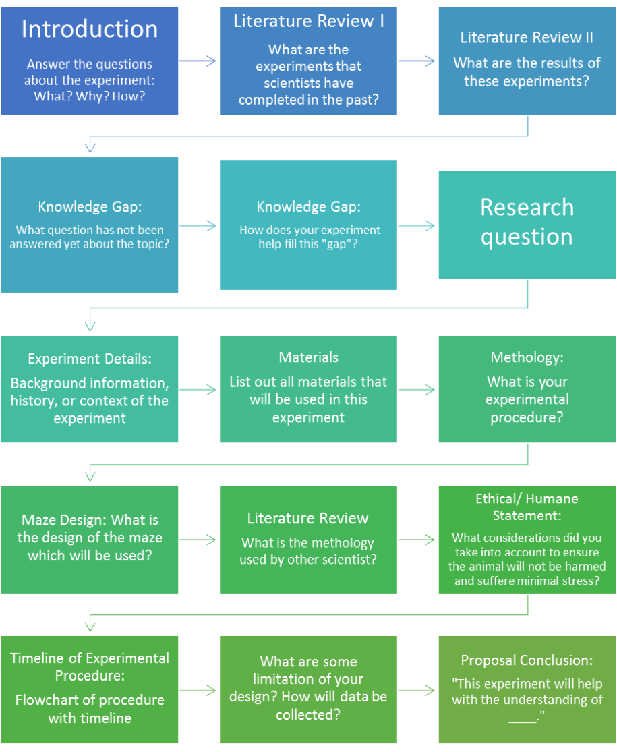

Research Proposal
Introduction:
From most of the people’s point of view, men tend to be more successfully learning, working, or dealing with science and math. However, in the scientific way, there is no evidence supporting the thought. On the other hand, the finding states that there is almost no differences in learning abilities between genders. Even that, the society does affect the abilities of the two sexs involving in the career of science and mathematics as the people may be influenced into or kicked out from science career because of the social believes
(Halpern et al., 2017). Otherwise, the genders’ abilities on both math and physics would be the same. According to the finding, the statement was leading to the experiment on whether the genders brains are the same? To be proven, the experiment should be conducted without any other factors affecting the variable. Therefore, instead of using human, the hamsters will be used to see the differences. The experiment will prove the beliefs which will be useful to gain women’s rights that all the women has the same abilities as men, so no one is going to be deprived from any roles or jobs.Even though, the result is projected to turn out as male hamster has the better learning abilities than females hamsters.

Background Information:
The mice and the hamsters were able to improve their timings. The experiment was showing that they were learning and remembering the inside pathway of the maze in every shot. However, the mice could complete the maze faster than the hamsters. The hypothesis that both hamsters and mice are able to learn and remember, but mice are able to learn faster than hamsters is genuine proven (“Comparing the learning abilities of hamsters and mice,” n.d.).
According to the EFTEM cytochemistry and sexual dimorphism of secretory granules in hamster male and female submandibular glands experiment, osmium tetroxide post fixation of the acinar cells of the male hamster submandibular gland, secretory granules exhibited the characteristic bipartite substructure with the electron lucid rim and the denser central core. The ultrathin sections were counterstained with uranyl acetate and lead citrate. In females, the reverse was seen, with the larger central portion of granules being electron lucent and the crescent being electron-dense rim with counterstaining (Keiichi, Michiya, & Norikazu, 2011).
This is found in the newborn tyrosine gland too. The Hamster Salivary Gland Sexual Dimorphism. 1. Protein Histochemical Study experiment indicates that the secretory cell elements were slightly more reactive than the reasonably stained ductal mechanisms. According to our observation in their reaction across their sex, there are no differences. At 8 days, variations in histochemical reactions between the male and female submandibular gland were initially exhibited. The strong, homogeneous, secretory cell response in male was more pronounced and revealed less divergence in staining intensity from cell to cell than in female. Staining differences between the sexes were even more obvious in the ductal cells (Kronman, 1963).
The result from the Hamsters (Mesocricetus auratus ) use spatial memory in foraging for food storing experiment states that hamsters have moderately good spatial memories and can remember daylight changed for several weeks. The evidence from anecdotes indicates that hamsters be able to recall familiar humans for months or even years. However, the exact length of time that hamsters can hoard memories cannot be quantified. The research indicated that spatial memory plays an important role in the hamsters’ food foraging. If hamsters were placed in a maze, they remember which branches had food and tend to explore those first even after several weeks. Researchers found that hamsters can remember daylight changes for two to three weeks and sudden interruptions of their circadian rhythms by changing light patterns affect their memories (Jones, McGhee, & Wilkie, 1990).
Female hamsters are smellier due to the courtship behavior which is much bigger than the male hamsters to handle the pregnancy. Only female hamsters that have nipples. The back end of the male likely to be lengthened and rounder in display compare to the female (“Are boy hamsters better than female hamsters?,” 2012).
Hamsters have a thick fur, chubby body, very short tail with cheek pouches and uncommunicative burrowers and hoarders. Hamsters’ routine is active at night and sleep during the day. They also have no distinguishable body odor and subject to very few health problems and diseases. (“Hamsters,” n.d.).
Hamsters favorite foods are a small cube of apple, carrot or cucumber. Normally, hamsters love carrots but don't give hamsters too much carrots. This is because carrots have high sugar level. In addition, the other fruits and vegetables that hamsters may like are chicory, cauliflower, broccoli, pear, peach and banana (“Hamster Food: What do hamsters eat?,” n.d.).

Literature Review :
According to experiment on comparing the learning abilities of hamster and mice, hypothesis was both hamsters and mice are able to learn and remember but mice are able to learn more quickly than hamsters. Independent variable of this experiment is learning abilities of hamster and mice, dependent variable is time taken for animal to complete the maze. The result of this experiment proved that this hypothesis is true so mice can run faster than hamster (“Comparing the learning abilities of hamsters and mice,” n.d.). This experiment is important because it show that hamster be able to run through the maze and did not take a long time so the experiment can be done easily. The result from this experiment also shows that the more trials animals participate, the less time they use to finish the maze. Hamster uses less than one minute to complete the maze. This experiment used Wikipedia as website to do the research so it can be improved by using more reliable sources to use as a citation. This experiment can be applied to the experiment that will be done that it should find some basic information form reliable sources such as the pethamstercare.com and hamsterific.com. Even though this experiment used information from unreliable source, it still provides useful background information for reader to have basic understanding about this experiment. It also provides detailed procedure and materials list. A good report should contain in-depth information about the experiment. Other people can follow the procedure and prove whether the result of the experiment is acceptable or not. This experiment illustrated the data by both table and graph which get more attention from reader than text. These ways are the best way to communicate and show other people about your data. These are the good parts of this experiment that can be applied to the experiment that will be done.
The second experiment by Kayla Cartwright was finding the effect of different foods on time taken to find food. Hypothesis of this experiment was hamster will run fastest if the food is doughnuts than if the food is corn or pellets. The result of this experiment stated that hamster can run fastest if the food is pellet so the hypothesis was wrong. The time taken for hamster to complete the maze and eat pellet was two hours and forty minutes (Cartwright, 2014). This experiment used only one hamster while the first experiment uses three hamsters which mean that the first experiment is more reliable than this experiment. This experiment should use new maze for the safety of hamster in the maze. The maze looks very weak and can easily fall apart. The wood use for making the maze was very thick and have burr come out of the plate. The burr can hurt the hamster if it runs near the wood. This maze is not safe for hamster. Also, the wood was not merge perfectly with the wall so hamster can see through the maze. The maze that will be use in this project will be made of feature board for light weight and will have a higher quality than the one that is used in this experiment. The results of each experiment were totally different. Because the size of maze and the environment that hamster live in make the time for hamster to complete the maze. The similarity between the first experiment and the second experiment is the type of maze. Both experiments use the classical maze which is the same type of maze that we use. The difference of the maze is the position of barriers inside the maze. The first experiment’s maze design has seemed to be more complicated than the second maze. This experiment gives essential information for the experiment that will be done. It gives the knowledge about the food that hamster prefer to eat. The result stated that the hamster run fastest when the pellet was used to be the reward at the end. This means that hamster prefer to eat the pellet the most so the hamster should be fed by pellet. This experiment also helps to determine the reward placed at the end of the maze. The reward should be the regular food that was given to hamster. This way hamster can recognize the smell and run to the finish line faster than using new type of food which has different smell from the regular food it has. The other similarity between the first experiment and the second experiment is how the data was collected. The data from both experiments were illustrated by the graph. The graphs show the relationship between number of trial and the time used by the hamster to complete one maze. Graph is the best way to present the data from the experiment to other people because it is easier for people to understand the graph than to understand text or other type of presentation.
The third experiment’s by Cristian Nalbandian was finding the answer of the question “will a hamster search for food faster if the reward which is food was placed at the end of the maze”. The hypothesis of this experiment said that the hamster will complete the maze faster if the reward was placed at the end. This result represented the use of counter conditioning to train the animal. The stimulus of this experiment is a food at the end of the maze (Nalbandian, 2014). The reward at the end stimulates the hamster to finish the maze so hamster can get food. The connection between this experiment and the experiment that will be done is the reward at the end of the maze. The hamster in example experiment and the experiment that will be done will get some food as a reward when hamster completes the maze. The food as mentioned act as the motivation for hamster to finish the maze. The procedure of this example experiment was not go on detail so it should be more specific on what type of hamster and should clarify which treat did it applied in this experiment. This experiment did not show how the maze looked like even though it must be shown in the presentation of this experiment. The similarity between the first experiment and the last experiment is how the data was shown. The data from both experiments were illustrated by the table. The table of the first experiment contained 9 columns and 11 rolls while the table from the second experiment contained just the 2 columns and 5 rolls. These number shows that the first experiment was done by more attention than the second experiment. The experiment in this project should also be done with more attention and carefulness.
Knowledge Gap: The question that did not answer yet about the topic is about the result of the experiment. Some experiment show that male and female have no different in ability of memorizing but some research show that male can memorize better than female. The result of the memorizing ability of rodent still on debate because there are no research that understand all information about the rodent behavior. In our opinion, we think that male hamster will use less time to finished the maze. We will answer the question about memorizing ability of male and female rodents by doing the experiment in animal behavior class. Our experiment using sex of the hamster as an independent variable and how fast can the hamster run as a dependent variable. We hope that the result from our experiment will reveal some fact that will be benefit for understand rodent spatial memory behavior.
Hypothesis: If both male and female hamster are treated equally, then a male hamster will use less time to complete the maze compared to female.
Research Question: Can male hamster learn to finish the maze faster and better than female hamster ?
In this experiment, faster is defined as the time that each hamsters take to finish the maze in which the one that use less time will be considered “faster.” A term “better” is defined referring to the hamster’s ability to learn and improve depending on the times that each hamsters uses to finish the maze. The one that take less time to finish the maze in each trial's (start from the first trial and follow by second to tenth respectively) is considered to have better learning and improving ability. And the learning and improving ability of the hamster is directly related to their memory’s ability.
Overview of Experiment Details:
In the experiment, both male and female hamsters will run in the maze 5 times. Since the hamsters enter the maze, turn on the timer and record the videos. The data that get from all 5 times will be compare whether male or female has better improvement by seeing how much time the hamsters take in each time. Also, the video will be use for observe the hamsters’ learning and remembering ability by counting how many time that the hamsters repeat the same way that the hamsters already passed and faced the same dead-end.

List of Materials:
- Male and female hamster
- Hamster’s food (Vegetables)
- Water bottle for hamster
- Paper from boxes
- Glue and Tape
- Hamster’s shelther including the roof and some walls
- Containers for hamster’s food
- Hamster cage
- Timer
- Hamster’s toy
- Camera
Only 1 maze that was builded because maze design is the control variable
Methodology Literature Review: 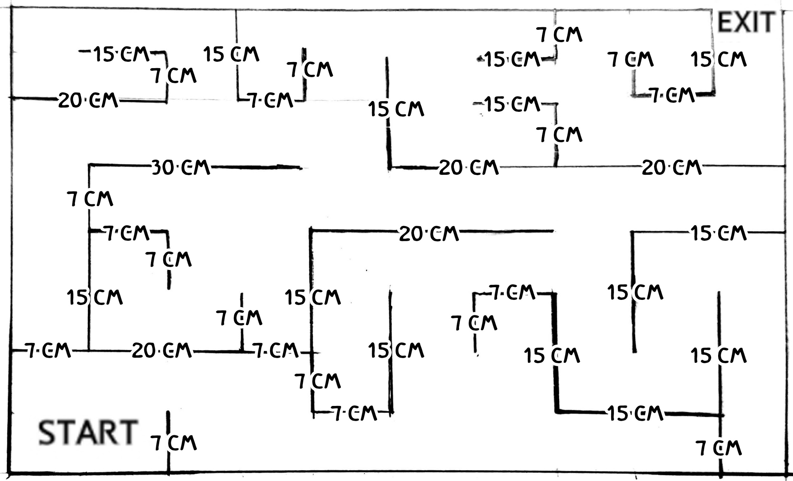
During every training, we will use timer to record the time that each hamster uses to complete the maze and video recorder to record the video that make we can observe the hamsters’ route weather they repeat the path that they already go through or not. With this methodology, we will be able to find out the answer for our research question. We want to find out that male hamster learn to finish the maze faster and better than female hamster or not, both in ability (include memory’s ability) to learn and improve in every time that each hamsters run on the maze.
According to the Morris Water Maze and Radial Arm Maze experiment, it is all science experiment about hamsters that let male and female hamsters swim in the water to get the food. This means that there are no any science experiment that hamsters will run on the maze yet. So, it a good opportunity to try to find out the difference in ability between male and female hamster by using the maze that set on a land and let hamsters run instead of swimming.
This maze was design for a hamster that has a large in size and weight. Since this maze is create for finding that a male hamster will use less time to complete the maze compared to female, the maze have to be a bit complicated. We design the maze to contain many dead end because we will compare the male and female intelligent by record the number of times that hamster walk back and faced the dead end again more than once.
We will keep our eyes on hamster all the time while the experiment process. Also, we will check the maze before let hamster run in the maze that there are no any barrier, the wall is strong, and the space to walk is big enough to for the hamsters.
When hamster become stressed the symptoms that displayed is similar to other mammals. They can become irritable and aggressive or the reverse, depressed and less active. They may also develop diarrhea and consequently lose weight, drink more water, and become listless. Therefore, if our hamsters don’t show any of this sign, we will then start to train it genteelly and not over load to avoid them to feel stress. Also, we will keep checking that both of it are not showing any sign that was mention above.
Methodology Literature Review:
For the safety of the animals and the appropriateness of the project, further research on the previous studies that relate to this project is necessary. The methodology of several studies conducted with the rodents are used as the guideline and source of information for this project. Initially, some ideas for the procedures are taken from a project called Comparing the learning abilities of hamsters and mice. The reason is that the sample experiment is conducted in the similar ways as what this project aims to be. The sample project measure the ability to learn of the rodents by timing the time that the animals used to finish the maze in each trials for 10 trials (“Comparing the learning abilities of hamsters and mice,” n.d.). Some of the ideas are applied to this project but some are not. Firstly, the mouse, which is used in the sample project, is not used in this project as this project aims to find the different of memory and cognition skill between male and female hamster not the mouse. However, the idea that the sample project will measure the learning abilities of the rodents through the maze by timing is such a crucial guideline to this project. Still, the method of timing is not enough to answer the question in this project, thus, the project is designed to time the time that the hamsters use to finish the maze in each trials along with observing the development of the hamster, for instance, observe that the hamsters do not make the same mistake by running to the same dead end twice, as those animals run the maze in order to have a better understand in more details of the hamsters’ memory skills. Moreover, the sample project is designed to let those animals run the maze for 10 times which is possible because only the time is observed. However, for this project, the hamster’s development need to be analysed, which is not included in the sample project, in every trails which would be too complicated to do that for 10 times and due to the time constraint that does not make this project possible for the experiment to be tested for 10 trials as the health of the hamster is needed to be concerned at the experiment is conducted. Secondly, the maze that is built in the sample experiment could provide some ideas to the maze that will be used in this project, however, some changes need to be made from the original maze to make the maze suitable for the purpose of this project (“Comparing the learning abilities of hamsters and mice,” n.d.). The maze in this project will be more complicated because the experiment aims to observe the development of the hamsters deeply, so, detailed maze is required. Moreover, the size of the maze need to be reduced, the maze’s size in the sample project is 100 cm x 200 cm (“Comparing the learning abilities of hamsters and mice,” n.d.). Due to the appropriateness of this project that the hamsters does not need to that big maze to run,this project, therefore, will create the maze with the size of 85 cm x 58 cm. Additionally, the sample project also provide a great suggestion that the maze should has a height at least 15 cm tall (“Comparing the learning abilities of hamsters and mice,” n.d.). So, the height maze for the project that will be done would be 20 cm tall. The main materials for the maze of the sample experiment is the cardboard box (“Comparing the learning abilities of hamsters and mice,” n.d.). However, the materials that will be used in this project would be the strong wooden base and feature board instead because those materials would provide more strength to the maze and the weight will be lighter than the wooden maze. After the maze is built, the sample project also suggests that the maze should be left for two days to let all the glue’s odour gone (“Comparing the learning abilities of hamsters and mice,” n.d.). This is such an important point that will be applied to this project because the odour from the glue could distract the hamster’s ability to smell the food during the maze experiment. Hamster has poor eyesight so hamster use odour to navigate the way to the food. If there is a glue odour, the ability to complete the maze will decrease. This sample project further shows the great way to test the rodents as the animals will be tested to run the maze every hour for one trial in order to keep the controlled environment and condition (“Comparing the learning abilities of hamsters and mice,” n.d.). This project is also designed to test the hamster in that way as that method would create the controlled and stable environment for the experiment. For the second study that has been used to this project as a guideline is called Hamster Maze Project which objects to find the effect of different food on the time that hamster will use to find the food in the maze (Cartwright, 2014). This research also test the hamster to run the maze without any food and record the time. The experiment is tested by putting the food at the end of the maze and let the find the food (Cartwright, 2014). Then, the time is recorded. The result come out that the hamster could finish the maze with the food, doughnut, corn and pellets, at the end of the maze faster than finish the maze without food (Cartwright, 2014). Therefore, the sample project provides such a useful information and this project is designed to use a food to stimulate the hamster to finish the maze faster. However, the food that is chosen for this experiment would not be the junk food, doughnut, as shown in the sample project (Cartwright, 2014). The hamster will be provided with the healthier alternative which is banana because banana has a unique odour that could be easily detect by the hamster. Moreover, the hamster does not use the sight as a main guide to mobile but this animal use the odour instead, thus, it is really important to provide the hamster with the food with strong odour. The last study that is used as the guideline is called Hamster Maze Time Trial Experiment which is conducted to find out whether hamster can navigate through the maze faster with a treat or without a treat (Nalbandian, 2014). This is similar to the previous study that is observe but this study still provide some evidence to guarantee that the hamster would finish the maze faster with the food as the study show the better performance of hamster by using less time while running through the maze with treat than without treat (Nalbandian, 2014). Therefore, these two sample experiments guide this project to the decision that the food will be added to the experiment as a stimulation to stimulate the hamster to run a maze.
Methodology:
For Maze:
- Find the feature board
- Cut the feature board into the size pieces that big enough for hamster(the height around 20 cm and the width based on the maze design)
- Use the large wooden sheet to make the maze base for the size approximately 90 cm x 60 cm
- Use hot glue to attach the piece of feature board to the base
- Attach the piece of feature board follow the pattern of the maze that was designed
- Wait for the glue to dry and check that the maze is ready to use. Also make sure that the odour of the glue is all gone
- Based on the maze design, the maze doesn’t has the open way to avoid the hamsters to run out off the maze through the open way. So, the hamsters will be placed at the start area
For the hamster:
- .At first, after hamsters arrive, the animals will be treat in a certain way to create the relationship among the hamsters and people. First, the hamster will be fed with a piece of peeled banana (1 cm thick)(unconditional stimulus) while a person who feed the hamster keep calling (Conditional stimulus) his/her name.
- Then, the hamster will respond by moving toward the food (unconditional response). As those steps are repeated many times, the hamster will start to learn that when someone is calling the hamster’s name, they will be likely to get feed.
- As a result, a conditional response is developed which is that the hamster will move towards a person at the time the hamsters’ names are called. Therefore, the hamster’s name will be called at the time that the experiment will begin.

For the Experiment:
Place a piece of banana at the end of the maze and place the hamster (one at a time) at the start point of the maze
Let the hamster run the maze as well as recording the video and timing the time at the same time.
After the hamster find the food, stop the time and video.
Record the data (time and video) as well as label the trail clearly.
Repeat step 1 to step 4 for 5 trials. The experiment (each trials) will be done every one hour in the same day to keep the environment constant. (The experiment will not be taken in the school day due to the time constraint.)
Maze Design:
Ethical/ Human Considerations:
The hamsters will be treated without any harms. Providing food, vegetables and fruits, that does not has the sour taste is required for the hamsters’ health. The hamsters’ cages will be always clean for hygiene. Also, the hamsters will not be forced to do the overload work by running so many times in short amount of time. The hamsters will be allowed to rest between each trials to restore energy. The maze will be made in the suitable size that fit the hamsters which will makes the hamsters feel safe and don’t be scared or lost.

Data Collections and Limitations:
For the data collection, we are going to run the experiment for 5 times for each hamster, male and female. We are going to time the time taken by the hamster to get out from the maze. Also, we are going to record the videos for each trial to compare and observe the routes that the hamster passes. When comparing the routes passed, we need to consider which trials that the hamster goes through the dead end way. If in the first trial, hamster ran into the dead end route and in the second round it doesn’t run into the dead end, we cannot assume that hamster already learn and remember that this is the way to dead end route. We also need to consider the result from the third round. If the hamster run into the dead end route in third round, we can consider that the second round is lucky that it did not run into the dead end not because it can remember the route. But if the hamster can pass the dead end route and finish the maze faster than the previous 2 route, we can consider that hamster can really remember the way to finish line.
For a limitations in this experiment are firstly, the amount of time is every limited because their is about two weeks before the experiment will be done. Moreover, there are a limited of two hamster in this experiment each hamsters will get to eat same kind food, same amount of food and train them in the same amount of trials. However, If there is still not perfect, the members will have to train them more. For example: Try to increases from 5 trials per each hamster - 15 trials because when increase to have more trials it will help to make a hamster become used to the things that stimuli them and remember the path way for a maze. Nevertheless, for the two hamster that will be use in this experiment might not created an accuracy and use to predict exactly behavior of the hamsters; but still can give an idea about how is the trend of the particular behavior will be like.

Conclusion:
As a conclusion, this experiment will be help to understand more about the learning process of the animal, the effect of stimuli on the animal learning process, the hamster life cycle and behaviour, and the biological differences among the male and female hamster as well as the differences of learning ability between genders. All of these can be figured out from the experiment as we use the two hamsters with different genders to run the experiment, we need to do the training for them to learn how to get out from the maze, and we need to treat and take care of them during the experiment period. That’s how we can learn and get to understand all the things mentioned about the hamsters.

Action Plan:
Task: | Date of Completion:
Planning on how to create the maze | 12th May, 2017
Buying materials | 11th May, 2017
Working on the final research report; introduction and background research | 12th - 15th May, 2017
Working on the final research report;  methodology, animal safety | 16th - 19th May, 2017
Building the maze | 20th - 21st May, 2017
Doing the experiment and recording data | 22nd May, 2017
Working on the final research report; data analysis and conclusion | 24th - 26th May, 2017
Due date: 26th May, 2017

Jones, C., McGhee, R. & Wilkie, D. (n.d.). Hamsters (Mesocricetus auratus ) use spatial memory in foraging for food to hoard. Retrieved in May 1, 2017 from from
https://www.ncbi.nlm.nih.gov/pubmed/24925848

Are boy hamsters better than female hamsters? (2015). Retrieved in May 1, 2017 from
https://hamsterdiaries.wordpress.com/2012/11/22/are-boy-hamsters-better-than-female-hamsters/
Hamsters. (n.d.). Retrieved in May 2, 2017 from
http://pethamstercare.com/

Hamster Food: What do hamsters eat? (n.d.). Retrieved in May 2, 2017 from

http://thehamsterhouse.com/hamster-food/what-do-hamsters-eat/
K. Joseph. (Jan 1, 1963). Hamster Salivary Gland Sexual Dimorphism. 1. Protein Histochemical Study. Retrieved in May 2, 2017 from
http://journals.sagepub.com/doi/abs/10.1177/00220345630420010501?journalCode=jdrb
Moriguchi F., Utsumi F., & Ohno F. (February 5, 2011).EFTEM Cytochemistry And Sexual Dimorphism of Secretory Granules in Male And Female Hamster Submandibular Glands.
https://www.jstage.jst.go.jp/article/ofaj/88/1/88_1_11/_pdf
Comparing The Learning Abilities of Hamsters And Mice. (n.d.). Retrieved in May 4, 2017 from
http://www.all-science-fair-projects.com/print_project_1101_78
C. Kayla. (November 7, 2014 ). Hamster Maze Project. Retrieved in May 4, 2017 from
https://prezi.com/uirewo5kj8dw/hamster-maze-project/
N. Cristian. (June 2, 2014). Hamster Maze Time Trial Experiment. Retrived in May 5, 2017 from
https://prezi.com/o05ehoda6adb/hamster-maze-time-trial-experiment/
http://www.all-science-fair-projects.com/print_project_1101_78
Comparing the learning abilities of hamsters and mice. (n.d.). Retrieved in May 3, 2017 from
http://www.all-science-fair-projects.com/print_project_1101_78

H. Diane,. B. Camilla,. G. David. (Dec 18, 2014). The Science of Sex Differences in Science and Mathematics. Retrieved in May 4, 2017 from
https://www.ncbi.nlm.nih.gov/pmc/articles/PMC4270278/
How Long Is A Hamsters Memory?. Retrieved in May 3, 2017 from
https://www.reference.com/pets-animals/long-hamsters-memory-b2a545f62b53b68b#
How Smart Are Hamsters?. (n.d.). Retrieved in May 2, 2017 from
http://www.rocketswag.com/animal/hamster/How-Smart-Are-Hamsters.html

For the hamster to get familiar with us:
- After bought the hamster, we will put it in the cage and leaves it alone for 2-3 days so hamster get familiar with the cage
- After get familiar we will feed the food from hand
- We will start to feed the hamster with banana from our hands(1 cm thick)(unconditional stimulus) while a person who feed the hamster keep calling hamster name (Hamham(female) and Taro(male))(Conditional stimulus)
- Then, the hamster will respond by moving toward the food (unconditional response). As those steps are repeated many times, the hamster will start to learn that when someone is calling the hamster’s name, they will be likely to get feed.
- As a result, a conditional response is developed which is that the hamster will move towards a person at the time the hamsters’ names are called. Therefore, the hamster’s name will be called at the time that the experiment will begin.
- we will clean the cage every 3 days and change the food(hamster food) and water every day
- Banana will be only used for the experiment and during training for familiar with human

For the experiment:
- Place a piece of banana at the end of the maze and place the hamster (one at a time) at the start point of the maze
- Let the hamster run the maze as well as recording the video and timing the time at the same time.
- After the hamster find the food, stop the time and video.
- Record the data (time and video) as well as label the trail clearly.
- Repeat step 1 to step 4 for 5 trials. The experiment (each trials) will be done every one hour in the same day to keep the environment constant. (The experiment will not be taken in the school day due to the time constraint.)

